



**Symphony Limited**

**DOCUMENTATION**

|  |  |
| --- | --- |
| **Group 2** | |
| **Group Member** | Đỗ Thị Diệp Quyên(Leader)  Nguyễn Anh Ngọc  Nguyễn Thanh Phong  Nguyễn Quốc Khánh |
| **Center** | ACE-HANOI-2-FPT |

- Hanoi, 12/2024 -

**Table of Contents**

I.Problem Definition 3

1.Introduction 3

2. Implementation Environment 3

II. User Stories 5

1. Admin 5

a. Administrative function: 5

2. User 5

a. View and Registration for courses: 5

b. Search exam result : 5

III. Use Case 6

IV. Flowchart 8

V. Database 9

1.DB Relationship Diagram 9

2. accounts 9

3. Categories 10

4. classes 10

5. courses 10

6. customerinformations 11

7. instructors 11

8. Feedbacks 11

VI. UI\UX 12

5.1 GUI 1 12

5.2 GUI 2 12

5.3 GUI 3 13

5.4 GUI 4 13

5.5 GUI 5 14

5.6 GUI 6 14

5.7 GUI 7 15

5.8 GUI 8 15

5.9 GUI 9 16

# I.Problem Definition

### 1.Introduction

In today's rapidly advancing technology landscape, having a modern and comprehensive learning platform is crucial. As the demand for IT professionals continues to rise, fueled by the growing reliance on digital systems across industries, individuals are increasingly seeking opportunities to enhance their skills and obtain certifications that will elevate their careers. The complexity and pace of the IT and software sectors require learners to have access to up-to-date, reliable, and well-structured resources, ensuring they stay competitive in a fast-changing environment.

This growing need has led to the creation of Symphony Ltd., a private training institute dedicated to providing high-quality courses and resources for a wide range of IT certifications. Symphony Ltd. is designed to address the needs of today’s learners by offering a one-stop solution for acquiring knowledge, preparing for exams, and enhancing practical skills across various IT and software domains. As digital transformation continues to reshape the way we work and learn, the importance of accessible, streamlined, and efficient learning platforms cannot be overstated.

Symphony Ltd. goes beyond traditional educational models by offering personalized learning experiences, comprehensive study materials, and interactive tools that enable learners to gain a deeper understanding of their chosen subjects. By integrating modern technologies into the learning process, Symphony Ltd. provides flexible options for students, including self-paced courses, instructor-led training, and hands-on lab environments, making learning more engaging and effective.

With the growing demand for skilled IT professionals, it’s essential for training institutes to stay ahead of the curve in terms of curriculum development, industry relevance, and student support. Symphony Ltd. understands this challenge and is committed to providing targeted certifications, updated content, and career guidance that ensures learners are not only prepared to pass exams but are also equipped with the skills needed to excel in the competitive IT job market.

In summary, Symphony Ltd. stands at the forefront of IT and software training, offering a comprehensive and innovative approach to learning that helps individuals advance their careers, gain valuable certifications, and remain at the cutting edge of the technology industry. Through personalized, accessible, and effective learning experiences, Symphony Ltd. is helping to shape the next generation of IT professionals, ensuring that they are ready to meet the challenges and opportunities of the digital age.

### Implementation Environment

The development of the "**Symphony Limited”** both flexibility and scalability, essential for delivering a seamless user experience.

**React:** The core of the front-end development was built using ASP.NET along with HTML and Bootstrap. ASP.NET was used to handle server-side logic and communication with the database, while HTML provided the structure and layout of the website. Bootstrap was leveraged for styling and ensuring a responsive, mobile-friendly design. This allowed the creation of a highly interactive and visually consistent web application.

**HTML:** The structure and layout of the website were created using HTML, providing the foundational elements required to display content and interface elements effectively.

**Bootstrap:** For the design and styling, Bootstrap was utilized to ensure a responsive and aesthetically pleasing user interface. This popular front-end framework allowed us to implement a consistent, mobile-friendly design with pre-built components, saving time and enhancing the overall look of the platform.

**ASP.NET (C#):** The back-end of the platform was built using ASP.NET with C# as the primary programming language. ASP.NET is a robust framework for building web applications and services, allowing efficient handling of HTTP requests, routing, and server-side logic. C# provided the structure for the business logic, making it easy to manage users, perform operations, and handle data.

Model-View-Controller (MVC) architecture was used to separate the logic of the application, making it easier to maintain and scale.

Entity Framework could be used to interact with the SQL Server database seamlessly.

SQL Server:

For data storage, SQL Server was chosen as the relational database management system. It stores critical platform data such as user information, travel details, bookings, and more. SQL Server's powerful querying capabilities and robust transaction management ensured that the platform could handle large amounts of data securely and efficiently.

# II. User Stories

## Admin

### Administrative function:

-View dashboard

-Allows adding, viewing, adding, editing, deleting students, classes, instructors.

-View feedback

## User

### View and Registration for courses:

Step 1: Customers access the Symphony website homepage.

Step 2: They are provided with popular courses or can go to "couse" to view all courses

Step 3: Customers can view details and register for courses.

Step 4: After successful registration, they will be sent the course ID via email

### Search exam result :

Step 1: Go to Exam Result

Step 2: Search information according to the ID provided by us

# Use Case

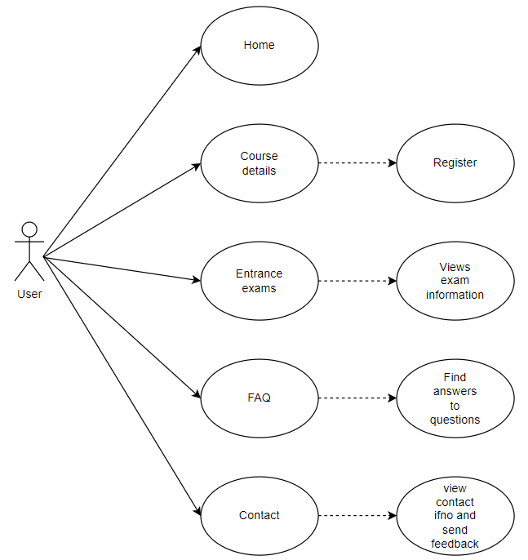

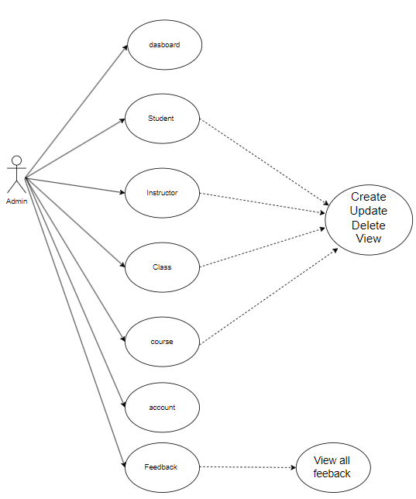

# IV. Flowchart

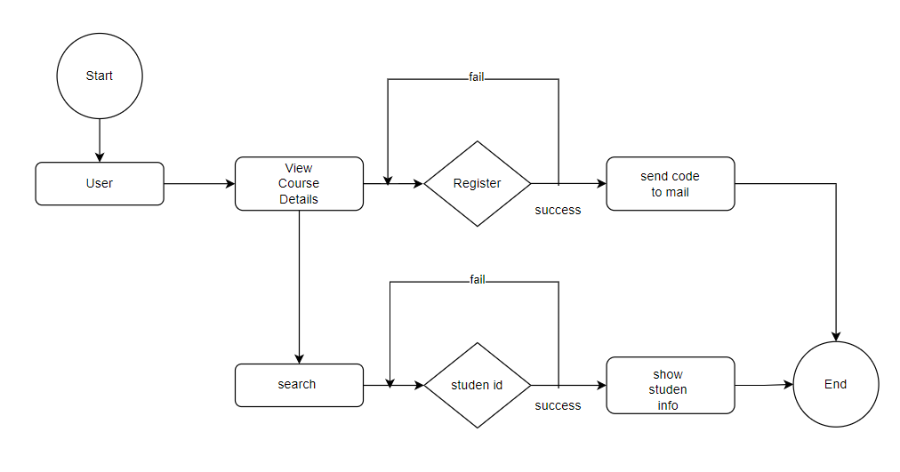

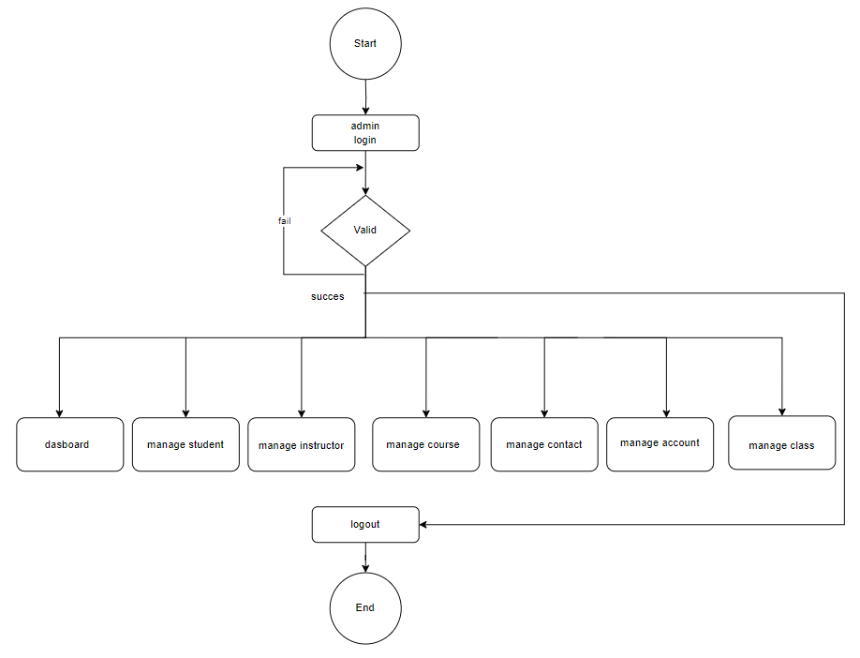

# V. Database

## 1.DB Relationship Diagram

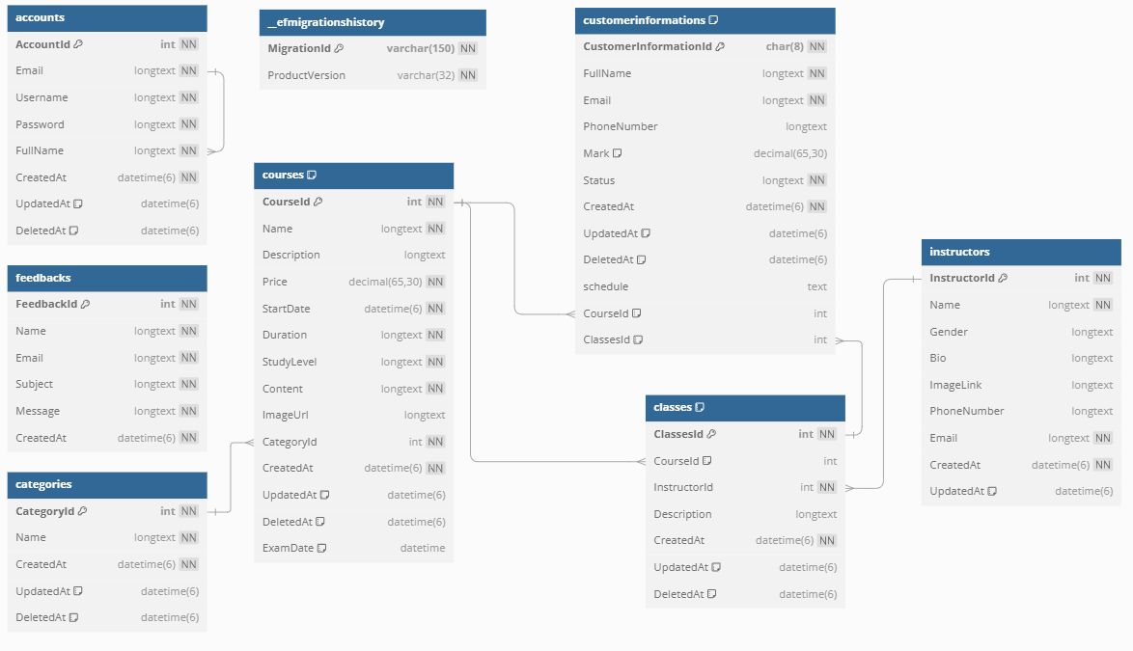

## 2. accounts

|  |  |  |  |
| --- | --- | --- | --- |
| Column Name | Data Type | Constraint | Description |
| AccountId | INT | PK, NOT NULL, AL | Primary of the table |
| Email | longtext | NOT NULL |  |
| Username | longtext | NOT NULL |  |
| Password | longtext | NOT NULL |  |
| FullName | longtext | FK, NOT NULL | Foreign key of  table |
| CreatedAt | datetime(6) | NOT NULL |  |
| UpdatedAt | datetime(6) |  |  |
| DeletedAt | datetime(6) |  |  |

|  |  |  |  |
| --- | --- | --- | --- |
| Column Name | Data Type | Constraint | Description |
| CategoryId | int | PK, NOT NULL, AL | Primary of the table |
| Name | longtext | NOT NULL |  |
| CreatedAt | datetime(6) |  |  |
| UpdatedAt | datetime(6) |  |  |
| DeletedAt | datetime(6) |  |  |

## 3. Categories

|  |  |  |  |
| --- | --- | --- | --- |
| Column Name | Data Type | Constraint | Description |
| CategoryId | int | Constraint | Description |
| Name | longtext | PK, NOT NULL, AL | Primary of the table |
| CreatedAt | datetime(6) | NOT NULL |  |
| UpdatedAt | datetime(6) |  |  |
| DeletedAt | datetime(6) |  |  |

## 4. classes

|  |  |  |  |
| --- | --- | --- | --- |
| Column Name | Data Type | Constraint | Description |
| ClassesId | int | PK, NOT NULL, AL | Primary of the table |
| CourseId | int | FK | Foreign key of table |
| InstructorId | int | FK, NOT NULL | Foreign key of table |
| Description | longtext |  |  |
| CreatedAt | datetime(6) | NOT NULL |  |
| UpdatedAt | datetime(6) |  |  |
| DeletedAt | datetime(6) |  |  |

## 5. courses

|  |  |  |  |
| --- | --- | --- | --- |
| Column Name | Data Type | Constraint | Description |
| CourseId | int | PK, NOT NULL, AL | Primary of the table |
| Name | longtext | NOT NULL |  |
| Description | longtext |  |  |
| Price | decimal(65,30) | NOT NULL |  |
| StartDate | datetime(6 | NOT NULL |  |
| Duration | longtext | NOT NULL |  |
| StudyLevel | longtext | NOT NULL |  |
| Content | longtext | NOT NULL |  |
| ImageUrl | longtext |  |  |
| CategoryId | int | FK, NOT NULL | Foreign key of table |
| CreatedAt | datetime(6) |  |  |
| UpdatedAt | datetime(6) |  |  |
| DeletedAt | datetime(6) |  |  |
| ExamDate | datetime(6) |  |  |

## 6. customerinformations

|  |  |  |  |
| --- | --- | --- | --- |
| Column Name | Data Type | Constraint | Description |
| CustomerInformationId | char(8) | PK, NOT NULL, AL | Primary of the table |
| FullName | longtext | NOT NULL |  |
| Email | longtext | NOT NULL |  |
| PhoneNumber | longtext |  |  |
| Mark | decimal(65,30) |  |  |
| Status | longtext | NOT NULL |  |
| CreatedAt | datetime(6) |  |  |
| UpdatedAt | datetime(6) |  |  |
| DeletedAt | datetime(6) |  |  |
| schedule | text |  |  |
| CourseId | int | FK | Foreign key of table |
| ClassesId | int | FK | Foreign key of table |

## 7. instructors

|  |  |  |  |
| --- | --- | --- | --- |
| Column Name | Data Type | Constraint | Description |
| InstructorId | int | PK, NOT NULL, AL | Primary of the table |
| Name | longtext | NOT NULL |  |
| Gender | longtext |  |  |
| Bio | longtext |  |  |
| ImageLink | longtext |  |  |
| PhoneNumber | longtext |  |  |
| Email | longtext | NOT NULL |  |
| CreatedAt | datetime(6) | NOT NULL |  |
| UpdatedAt | datetime(6) |  |  |

# 8. Feedbacks

|  |  |  |  |
| --- | --- | --- | --- |
| Column Name | Data Type | Constraint | Description |
| FeedbackId | int | PK, NOT NULL, AL | Primary of the table |
| Name | longtext | NOT NULL |  |
| Email | longtext | NOT NULL |  |
| Subject | longtext | NOT NULL |  |
| Message | longtext | NOT NULL |  |
| CreatedAt | datetime(6) | NOT NULL |  |

**9. Efmigrationshistory**

|  |  |  |  |
| --- | --- | --- | --- |
| Column Name | Data Type | Constraint | Description |
| MigrationId | varchar(150) | PK, NOT NULL, AL | Primary of the table |
| ProductVersion | varchar(32) | NOT NULL |  |

# VI. UI\UX

## GUI 1

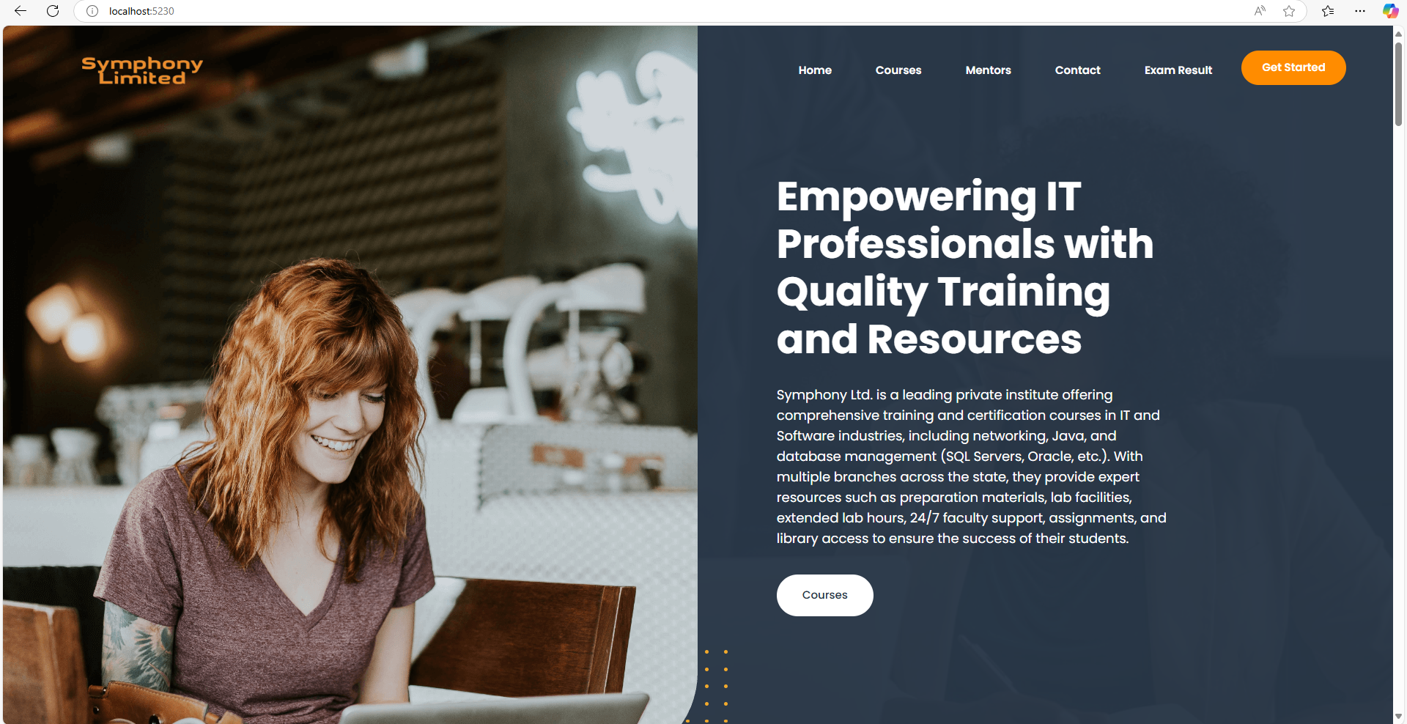

Home page

## GUI 2

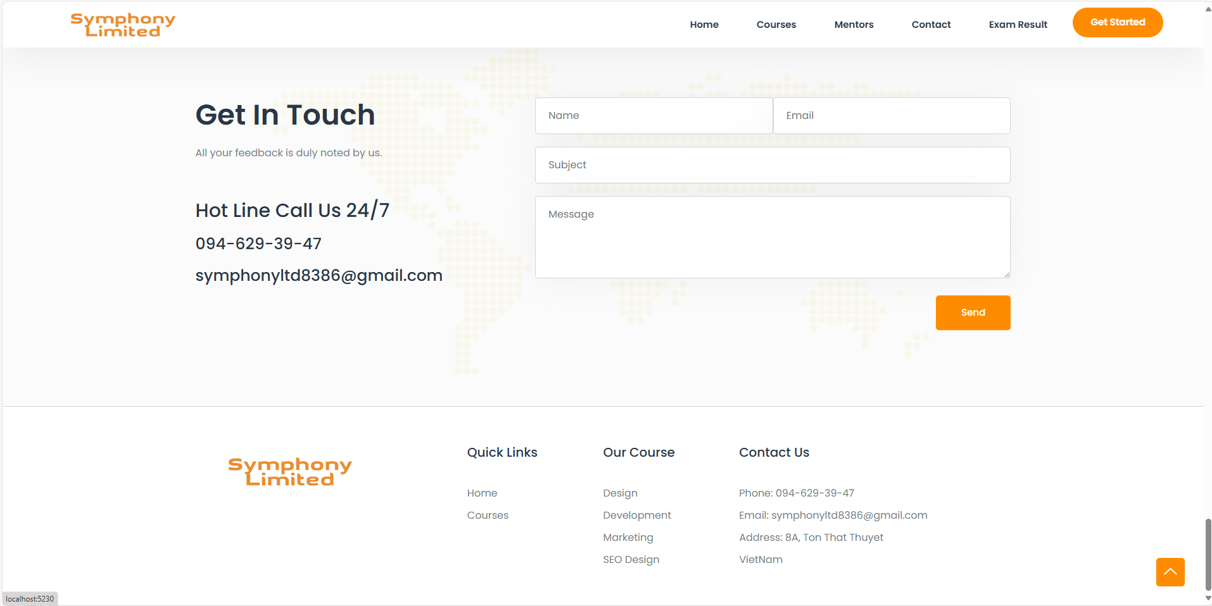

Feedback form

## GUI 3

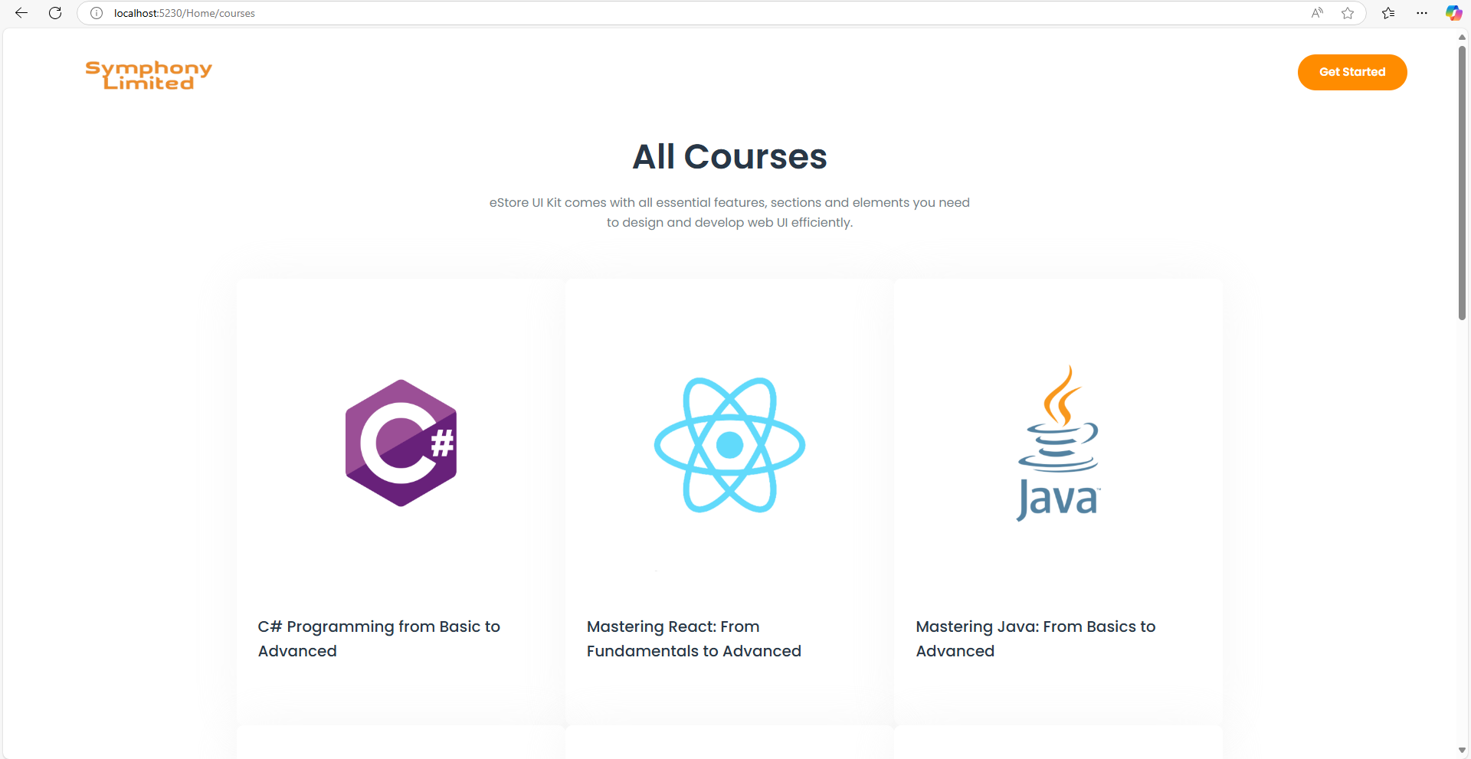

All courses

## GUI 4

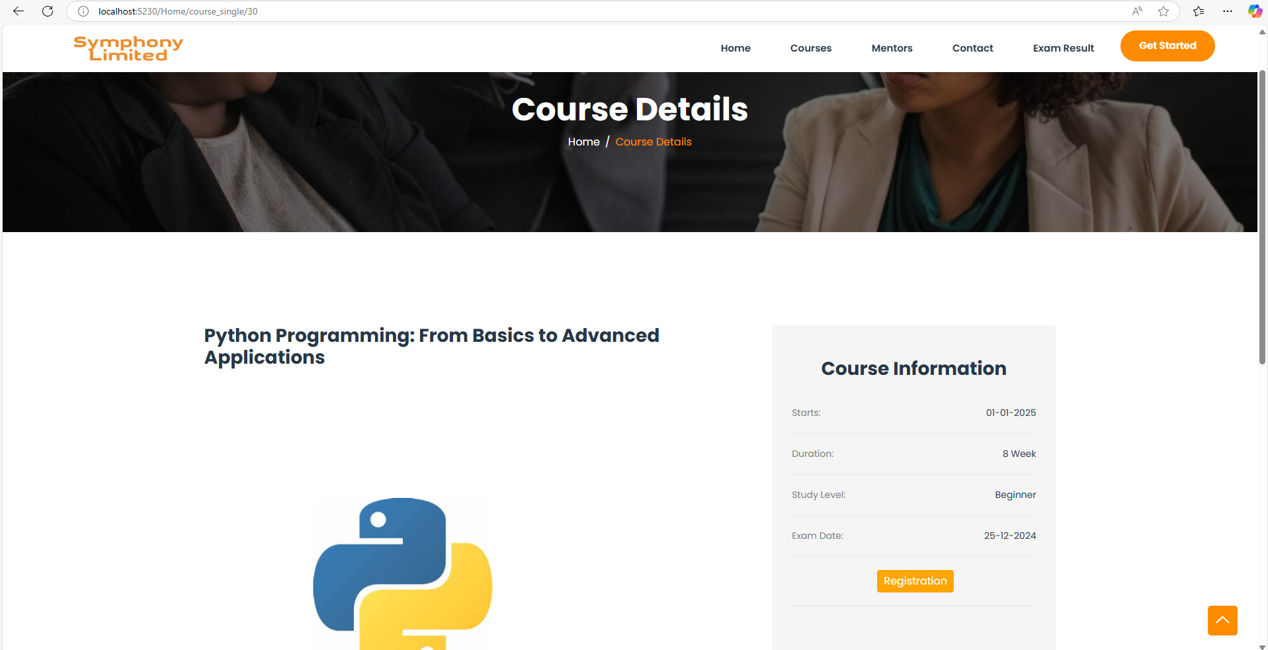

Course details

## 5.5 GUI 5

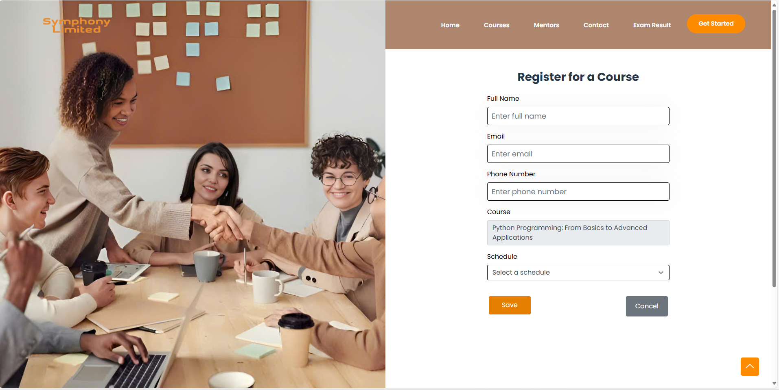

**Register for a Course**

# 5.6 GUI 6

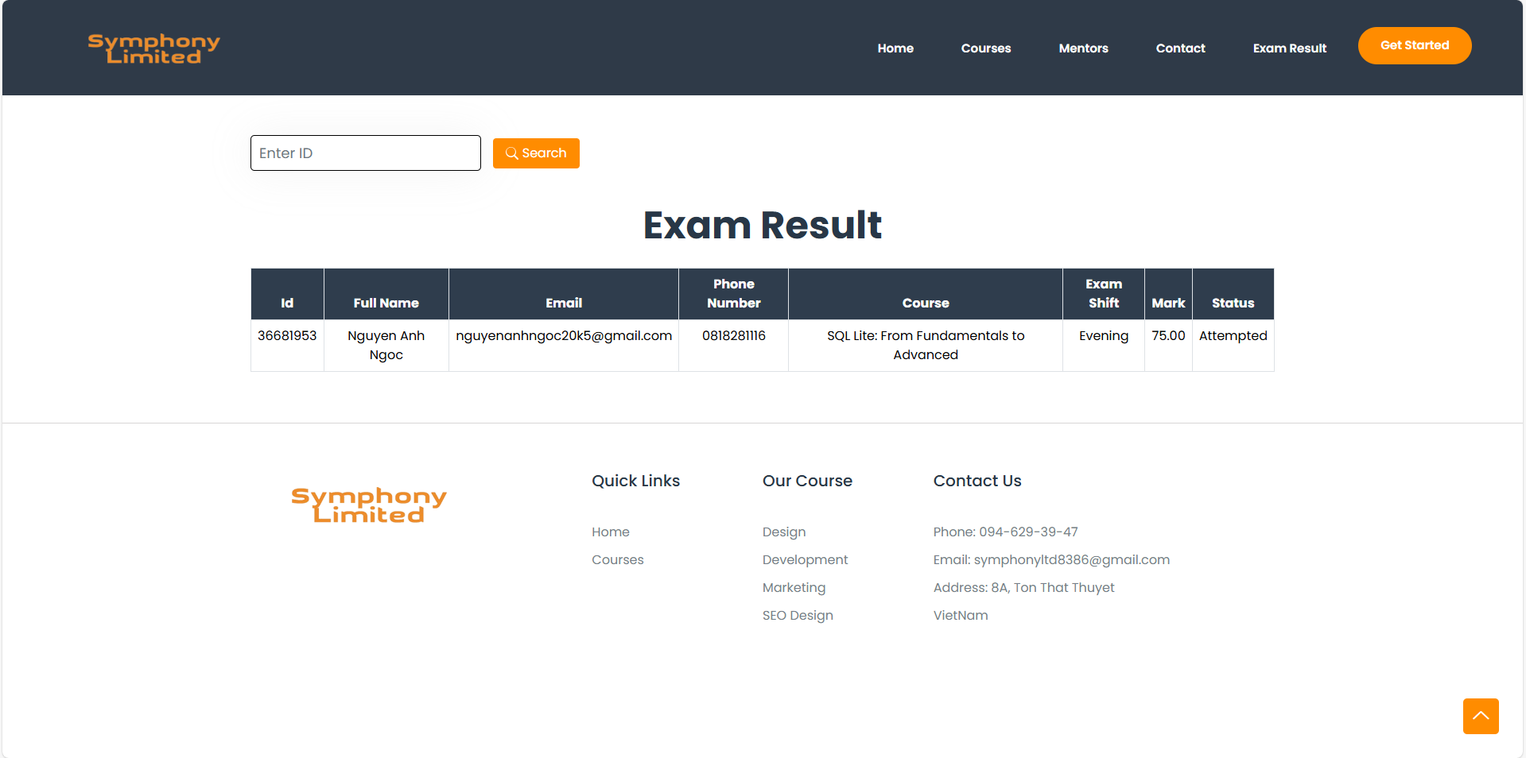

Exam result

# 5.7 GUI 7

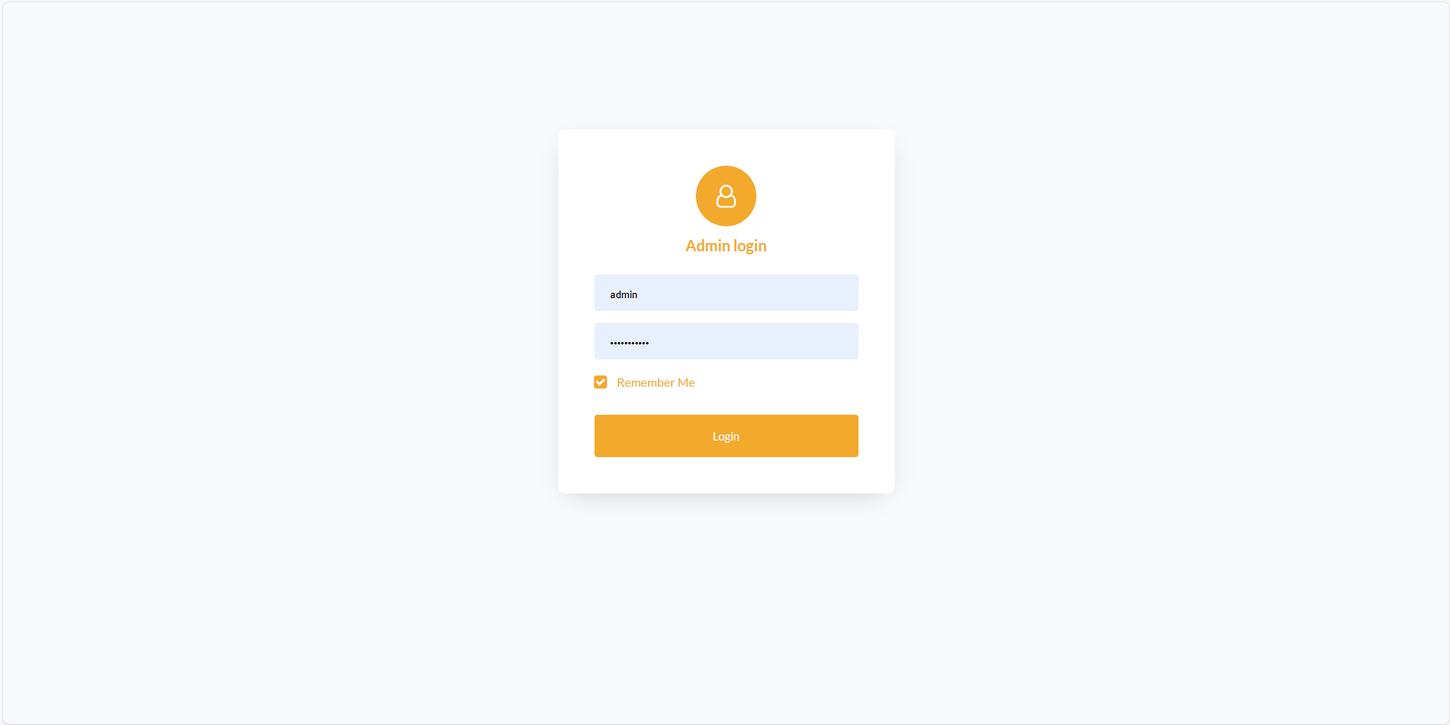

Admin login form

# 5.8 GUI 8

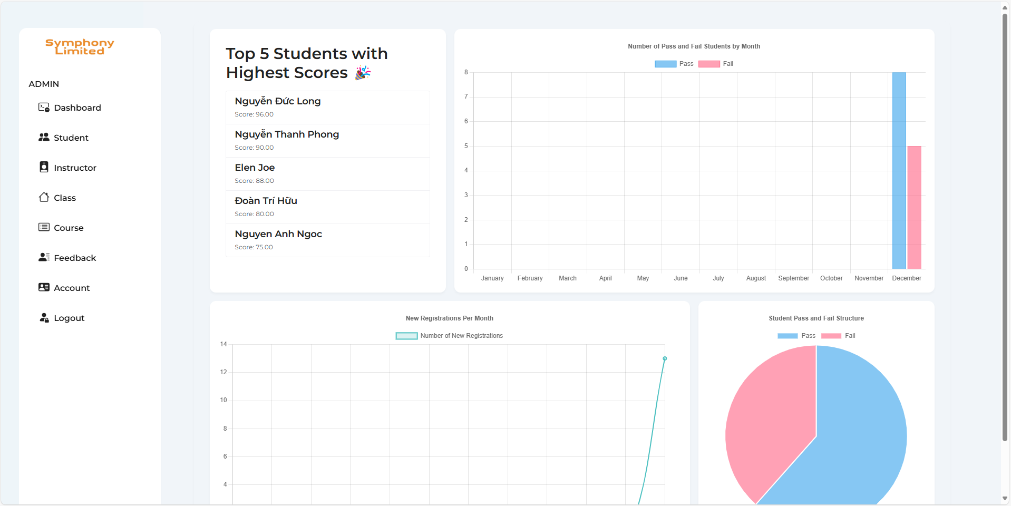

Dashboard

# 5.9 GUI 9

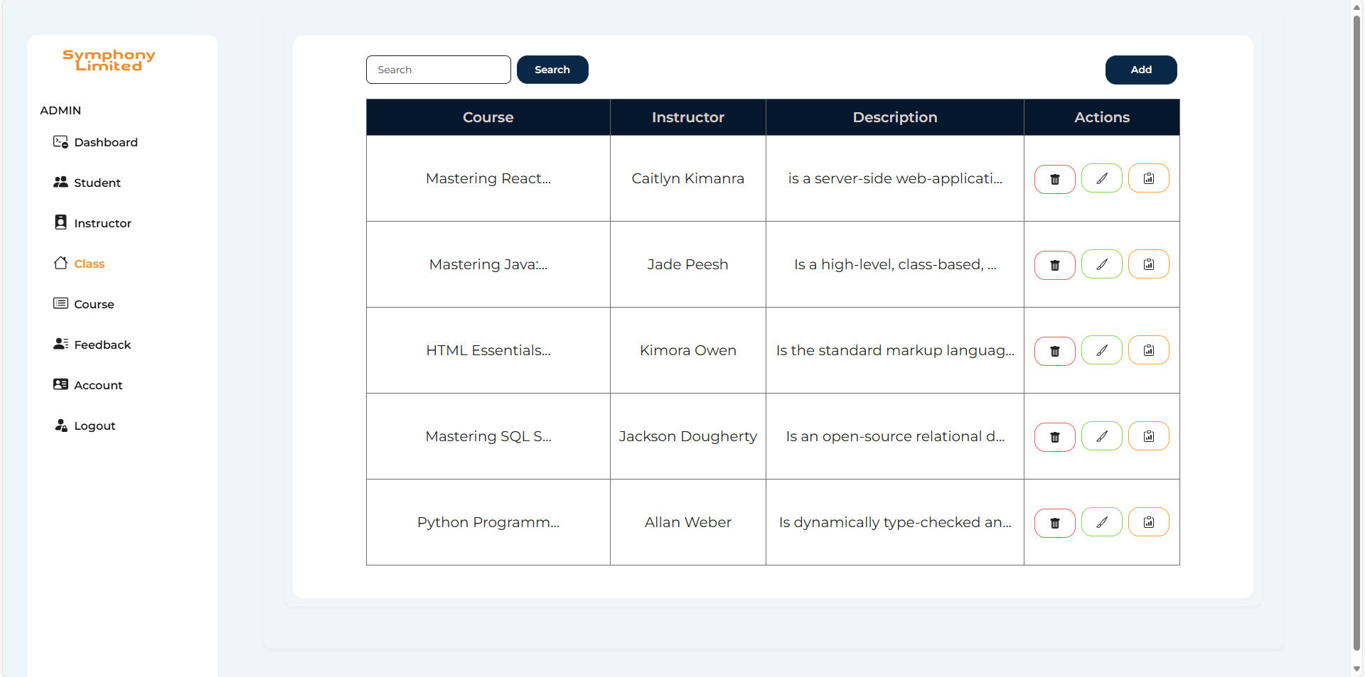VII.Summary

**Group 2** is participating in **FPT Aptech** Semester 3 project. The project is aimed at **Symphony Ltd**., a private training institute that provides courses and training materials for various IT and software-related certifications.

Currently, the project is in the branding and investment-seeking phase. The team is focusing on finalizing the PowerPoint presentation to attract investors, and developing and optimizing the functionality of the website to ensure the best user experience.

In addition, the project is also aiming to develop a mobile application in the future, allowing users to conveniently access and use the service on multiple platforms.

If you need more details or specific adjustments to the summary, please let me know!